

**Gulf Aluminium Rolling Mill B.S.C. (closed)**

Time & Attendance System

Overtime Online Approval

*User Guide Manual*

**Prepared by:**

Ervin Brosas

ICT Department

*Ext. No: 3152*

Table of Contents

How to Create Employee Overtime Request and Submit for Approval? 3

How to Approve an Assigned Overtime Requisitions? 6

How to Search for Overtime Requisitions? 7

How to Reassign Overtime Requisition to Other Approver? 9

## How to Create Employee Overtime Request and Submit for Approval?

1. Open the Time & Attendance System from the portal. From the Security Functions menu, click “**Employee Overtime Entry**” link as shown in the following screenshot.

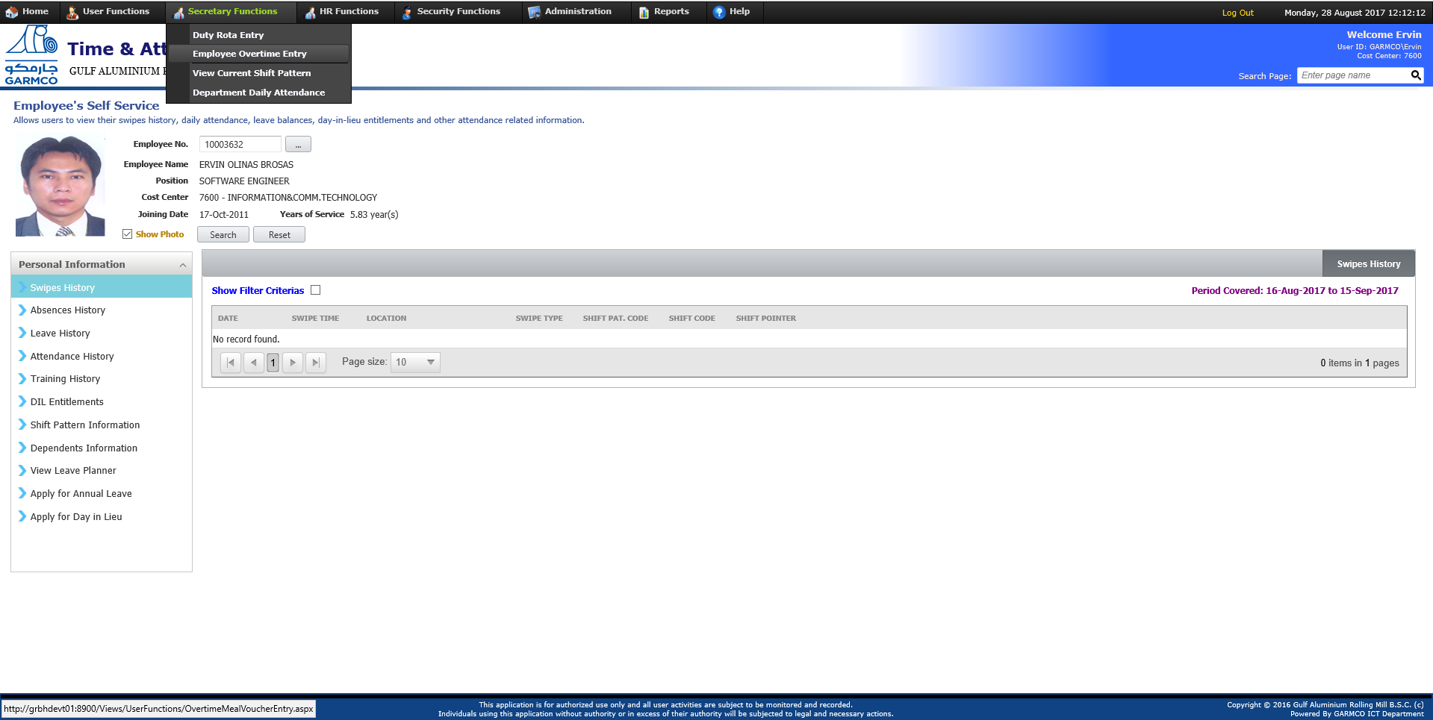

**1**

1. Select the pay period, cost center and then select “**Show unprocessed overtime**” in the Display Option search criteria field.
2. Click the **Search** button.

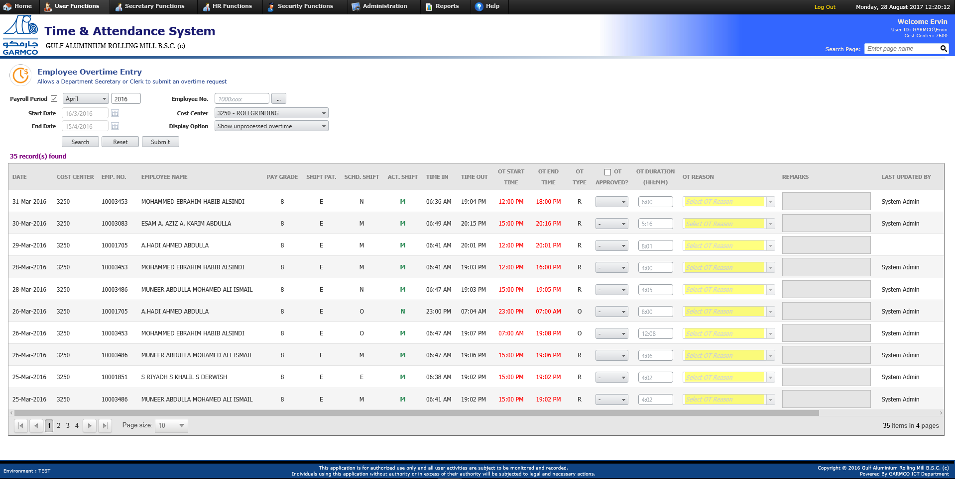

**3**

**2**

1. Select the employees whose overtime need to be approved or rejected and should undergo approval process.
2. Click the **Submit** button.

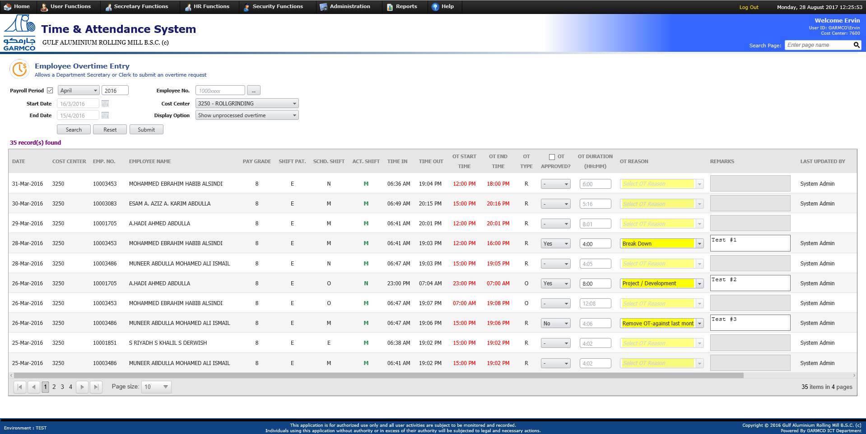

**4**

**5**

1. The list of submitted overtime requisitions will be shown in the form. To view information about the Routine History, Approval and Workflow Process History; click the **View History** link from the desired record in the grid.

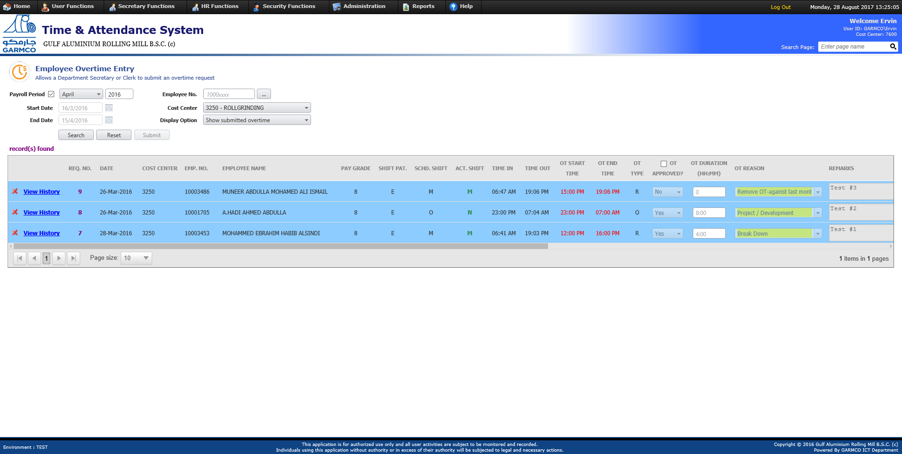

**6**

1. Click **Back** button to go back to the “Employee Overtime Entry” form.

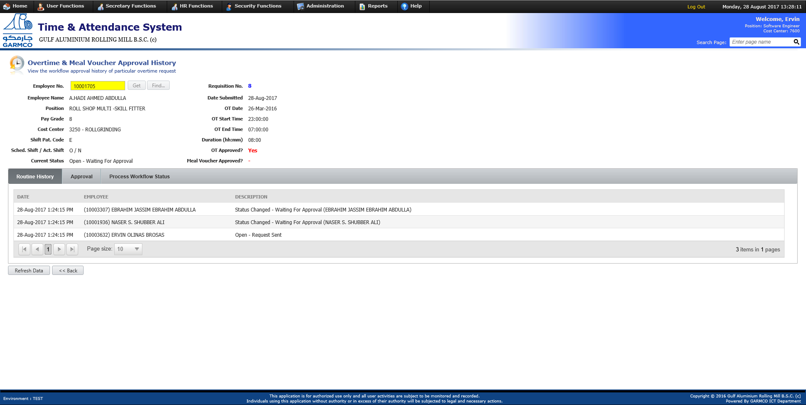

**5**

## How to Approve an Assigned Overtime Requisitions?

1. Open the Time & Attendance System from the portal. From the HR Functions menu, click “**Overtime & Meal Voucher Approval**” link as shown in the following screenshot.

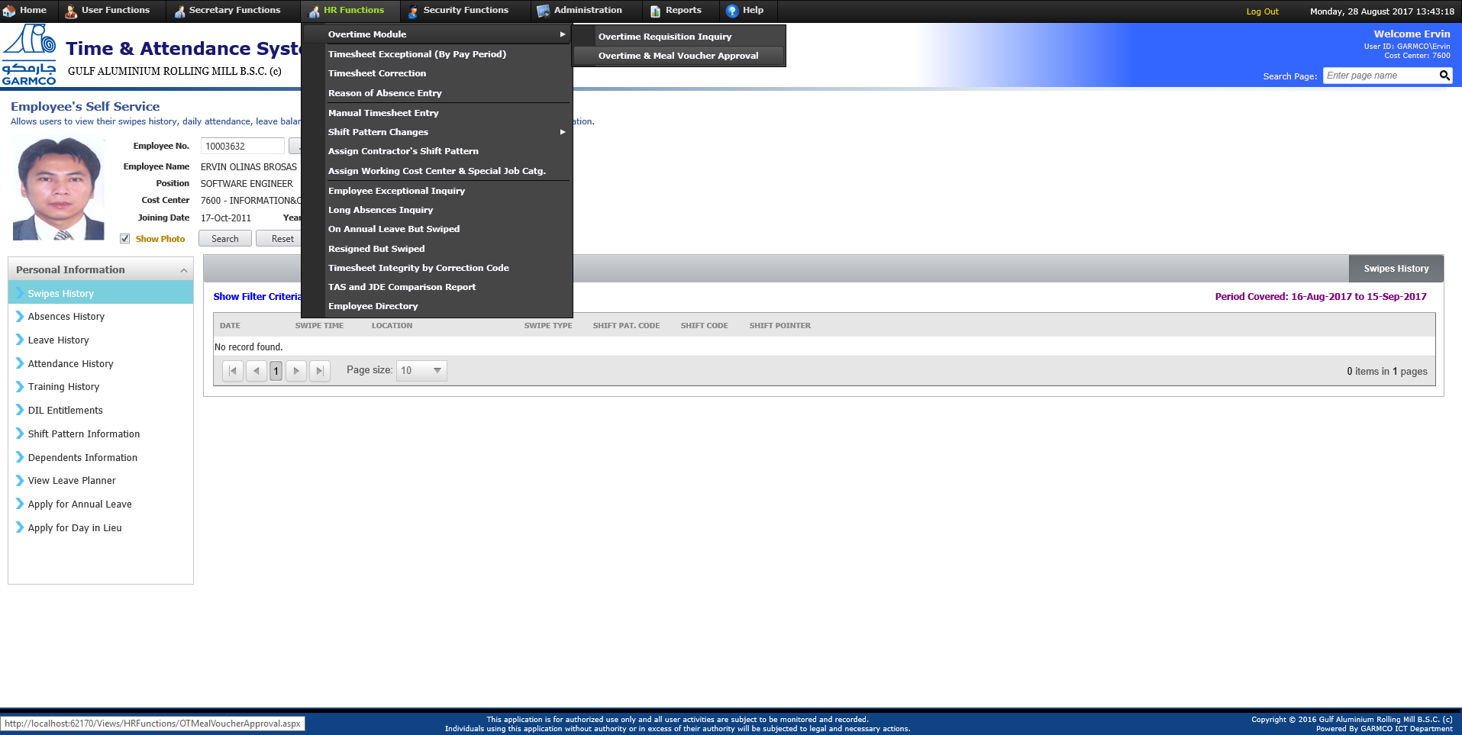

**1**

1. Select the overtime requisitions in the grid that need to be approved or rejected. Optionally, enter the comments then click the **Submit Approval** button. *(Note: There are 3 approval choices which are the following: [****Yes****] the default selection which means the OT request will be approved; [****No****] means OT request will be rejected; (****-****) means no action to be taken on the selected OT request. When a particular OT request is to be rejected, then the Approver Comments field becomes mandatory.)*

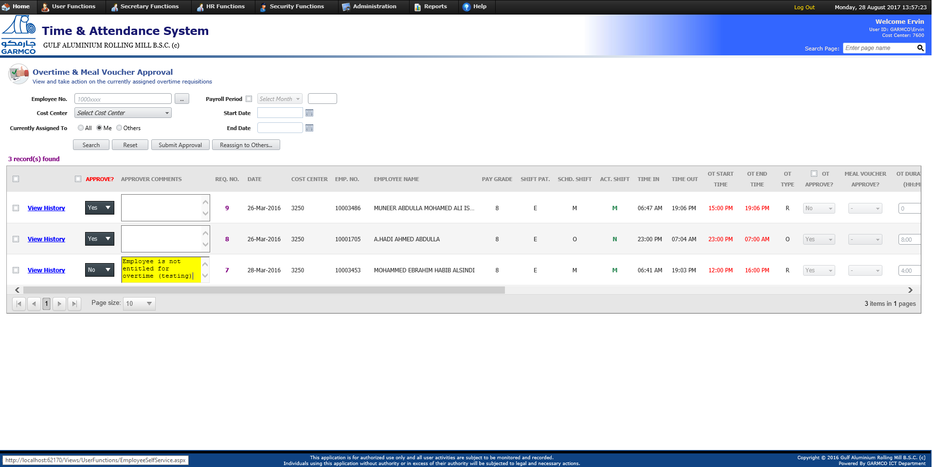

**2**

## How to Search for Overtime Requisitions?

1. Open the Time & Attendance System from the portal. From the HR Functions menu, click “**Overtime Requisition Inquiry**” link as shown in the following screenshot.

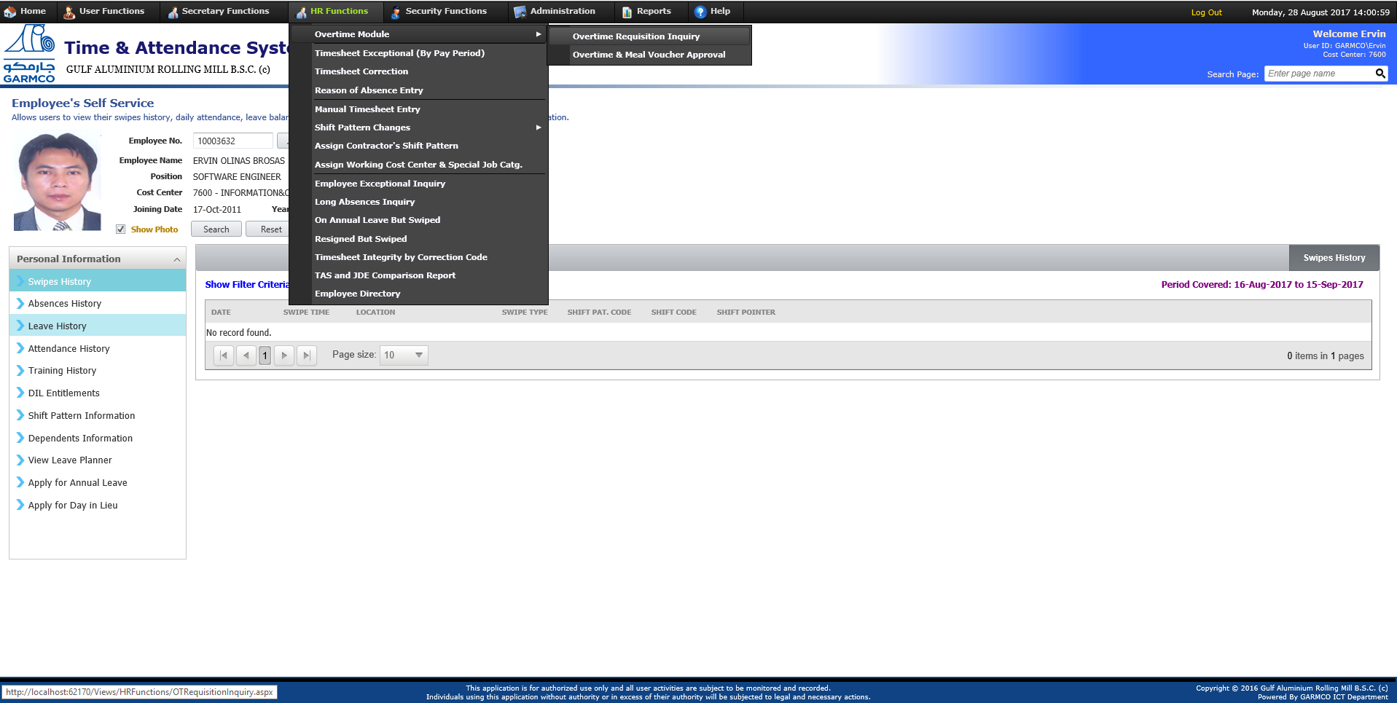

**1**

1. Specify the search criterias then click the **Search** button. Below summarizes the filter criteria fields and their meaning:
   * Requisition No. – to search for specific record wherein the requisition no. is known, then enter it in this field
   * Employee No. – to filter the search results by specific employee
   * Cost Center – to filter the search results by specific cost center
   * Created by Employee – to filter the search results by specific creator
   * Assigned to Employee – to filter the search results by specific approver
   * Payroll Period, Start Date, End Date – to search for overtime requisitions whose date falls between the specified date range
   * Status – to search for overtime requisitions based on the selected status which consist of the following: Open, Approved, Rejected, Cancelled and All Status

*(Note: By default, all the search filter fields are not set except the for* ***Status*** *field wherein the selection is set to “Open”. This means that all pending overtime requisitions will be fetched from the database when opening the form.)*

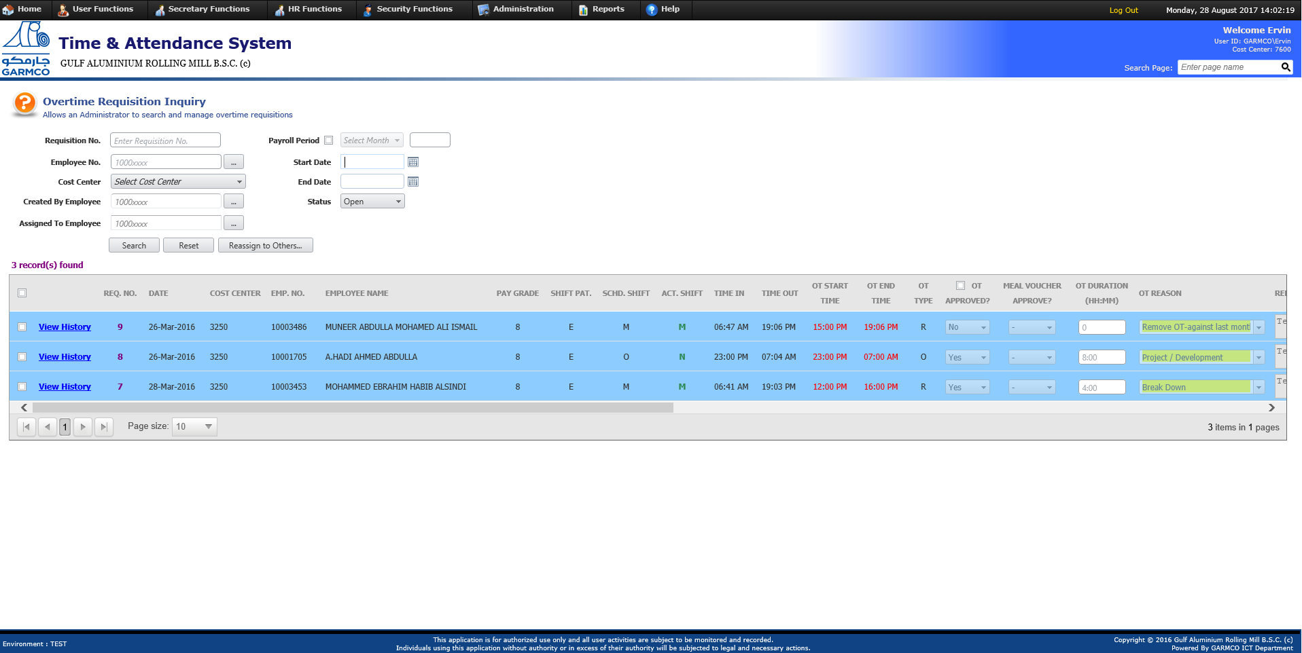

## How to Reassign Overtime Requisition to Other Approver?

1. Open the Time & Attendance System from the portal. From the HR Functions menu, click “**Overtime Requisition Inquiry**” link as shown in the following screenshot.



**1**

1. Search for pending overtime requisitions by specifying the filter criteria fields then clicking the Search button. Select the overtime requisitions that need to be reassigned by ticking the checkbox field in the grid then click the **Reassign to Others** button.
2. Click **Ok** in the confirmation popup window.

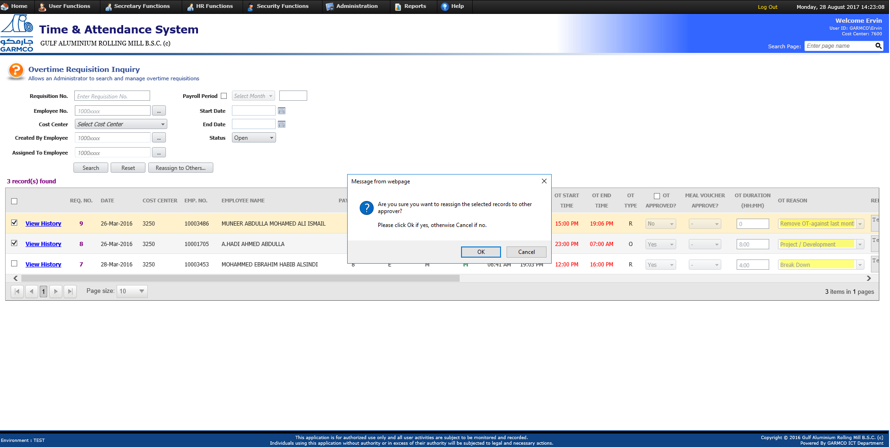

**3**

**2**

1. Enter the employee number of the person to whom the overtime requisitions will be reassigned. Put the justification then click the **Reassign** button. (Note: If the employee no. is not known, you can search for the desired employee by clicking the button beside the **Reassign To** field.)

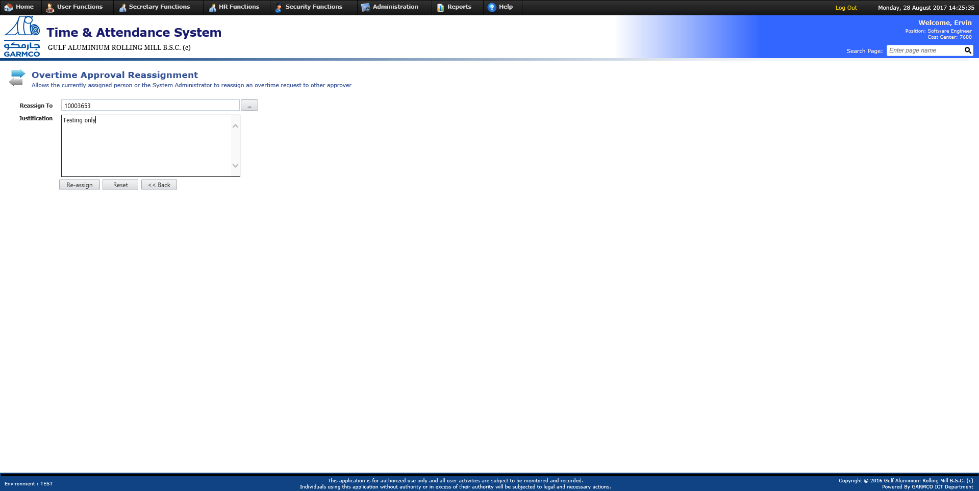

**4**

The system will send notification to the new approver about the reassigned overtime requistions as shown below:

